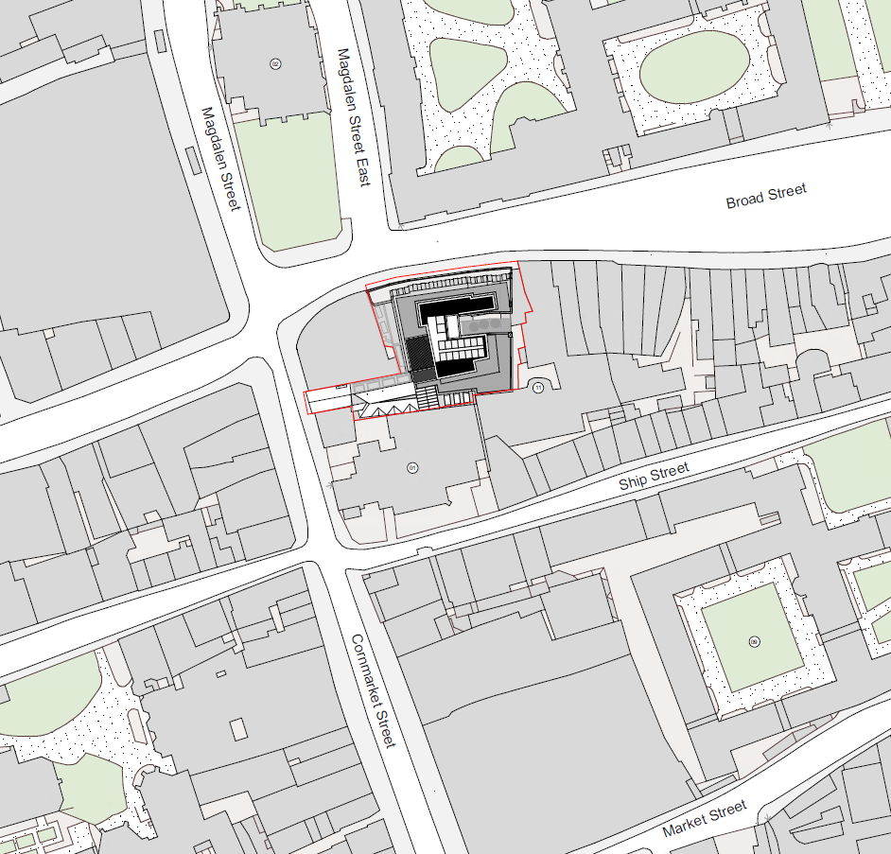
20/02480/FUL – Appendix 1 – Site Block Plan

